**Lab 1**

Alec Wood

SDEV 300: Building Secure Python Applications

October 26th, 2021

|  |  |  |  |  |
| --- | --- | --- | --- | --- |
| Test Case | Input | Expected Output | Actual Output | Pass/Fail |
| 1 | Name: John Smith  Age: 25  Citizenship: yes  State: TX  Zipcode: 78209 | Name: John Smith  Age: 25  Citizenship: yes  State: TX  Zipcode: 78209 | Name: John Smith  Age: 25  Citizenship: yes  State: TX  Zipcode: 78209 | pass |
| 2 | Name: Jake Smith  Age: 17  Over 18? no | Name: Jake Smith  Age: 17  Over 18? no | Name: Jake Smith  Age: 17  Over 18? no | pass |
| 3 | Name: Jack Smith  Age: 30  Citizenship: no  State: MD  Zipcode: 52432 | Name: Jack Smith  Age: 30  Citizenship: no  State: MD  Zipcode: 52432  Invalid due to citizenship | Name: Jack Smith  Age: 30  Citizenship: no  State: MD  Zipcode: 52432  Invalid due to citizenship |  |

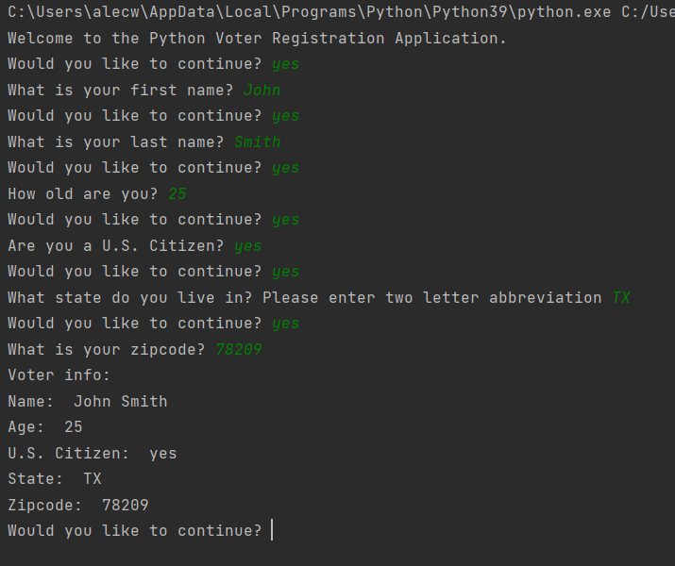

Test Case 1

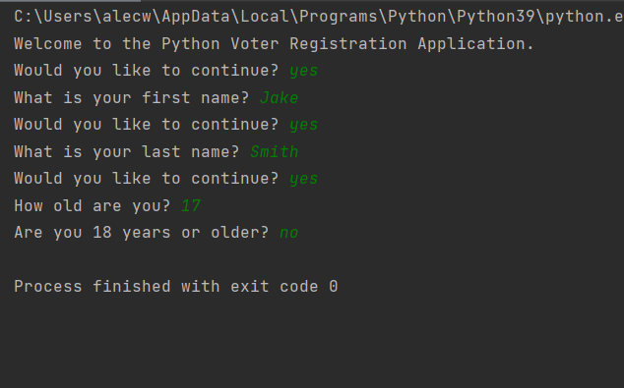

Test Case 2

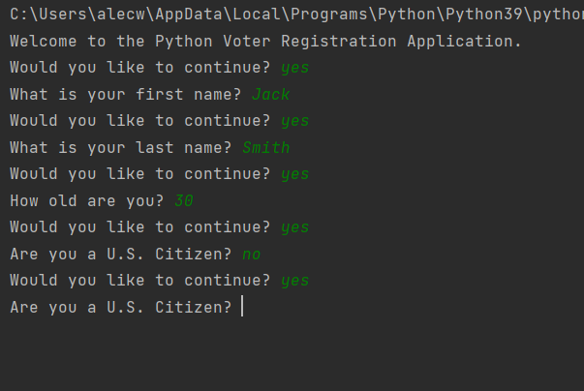

Test Case 3

PYLINT RESULTS:

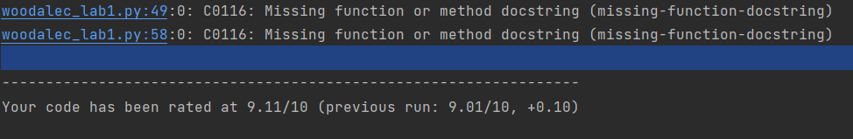

I had troubles searching and figuring out how to fix the above issue (C0116). I found many explanations but no fixes. Closest that I could get was 9.11.